Secure Programming Assignment 1 – Report – B00137882

In this report I examined a web application and had to highlight where the vulnerabilities take place and be able to show the code with the aid of screenshots and then finally being able to fix the code to prevent any exploits from occurring in the future.



The first vulnerability that I have came across was taken place in the Login.jsp page. On the page the user is asked to log into their account which seems normal but when it comes to the user having to enter the password, it does not hide the password that is being entered this is a big issue as there could be a hacker monitoring their screen and having the ability to view everything that the user is doing.

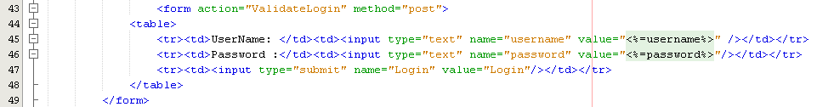

As you can see in this image on line 46 it shows that the type for the password is set to “text” this means that entered text will not be hidden when entered. To fix this issue I had to just change the type from “text” to “password”

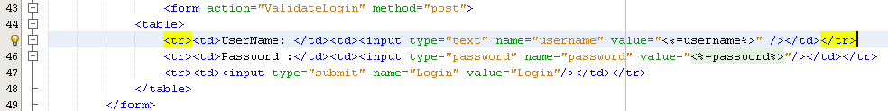

The final result:



**Problem 2**

The second vulnerability I came across was when a user is on the login.jsp page, if they entered ' OR 1=1;# they would be able to bypass the login and have access to all the sections only registered members have access to.



Result :



Here is the code that is causing this to happen:



After researching the OWASP website I came across on how to prevent this from happening with the aid of this code:



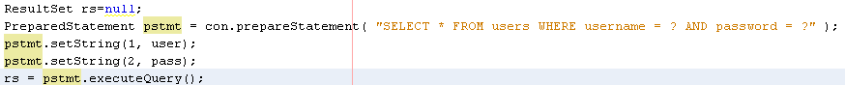

The result of this code redirects the user back to the login page whenever they enter that injection line of code.

**Problem 3**

The third vulnerability I have came across was that when you are logged in as any user, in the URL section you are able to change the “IDs” of the users which will log into any user and be able to view their account details and their credit card information.

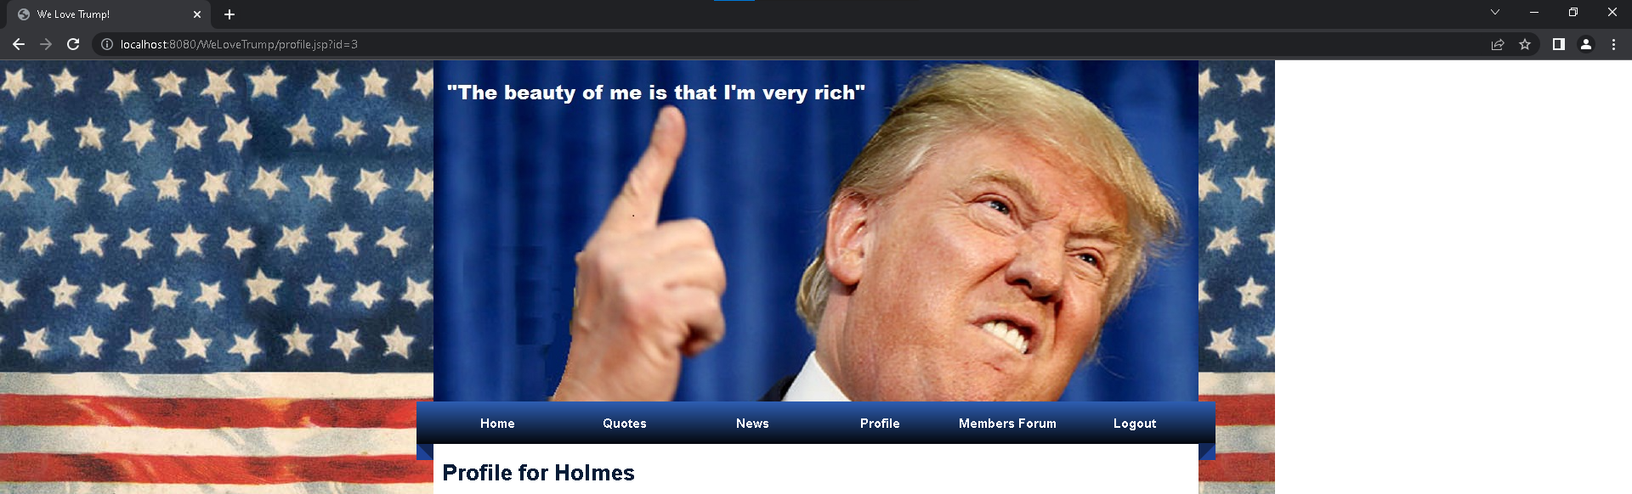

In this image I logged in as Holmes and I changed the ID from 1 to 3 which returns to me Colin’s account information and card details.

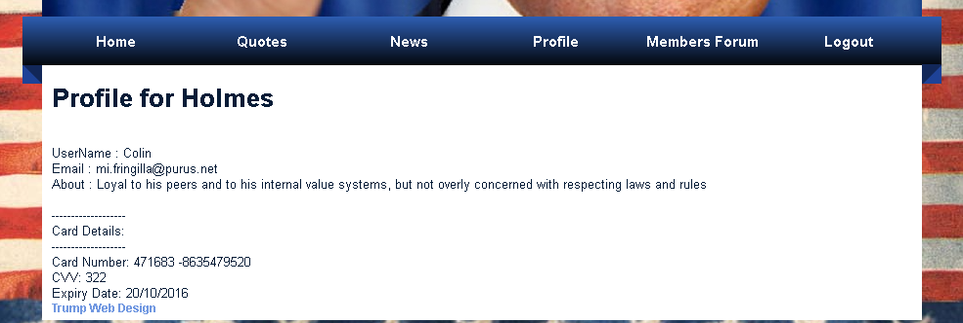

Here is part of the code which is found in the Profile.jsp page that causes this issue to happen.



On line 42 there is no session.getAttribute which means without that, it won’t use the userid that has been logged in in throughout the session, to prevent this from happening what has to be added to line 42 is && id.equals(session.getAttribute("userid"))

Code:



Result:



As you can see when I changed the ID from “1” to “2” it returns the same username, but it prints a statement saying (“ID Parameter is Missing”)

**Problem 5**

The 5th vulnerability I discovered that the website used “MD5” to store password and data’s, MD5 has been broken and it is extremely easy for hackers to find their way and get their hands on the protected data and password that are stored from the website. In ValidLogin.jsp there is a line of code that shows that it’s using MD5

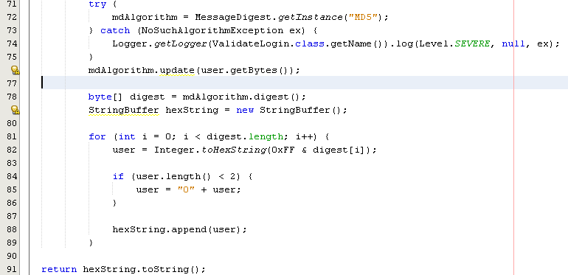

I went off and removed MD5 and added SHA256 as it is more secure, and it also has a hash value of 256-bits.

Final Code:

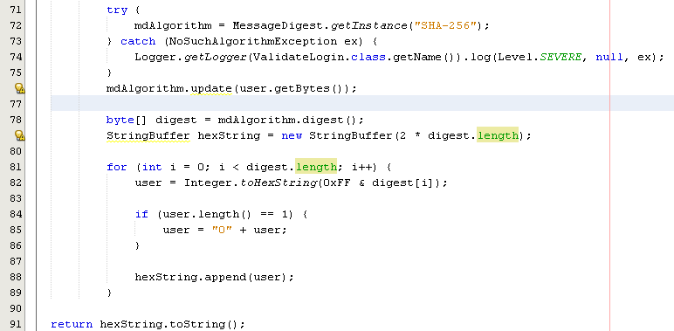

Here shows the cookies value and how they are protected.

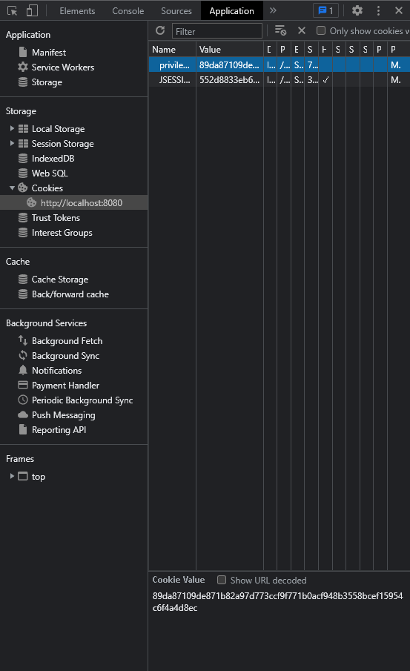

**Problem 6**

The 6th vulnerability I discovered was that a hacker was able to cross site script and be able to add “<script>alert(“XSS”)</script>” in a submission form and it will return an alert box which means they have the ability to retrieve private information from the website such as cookies, etc.

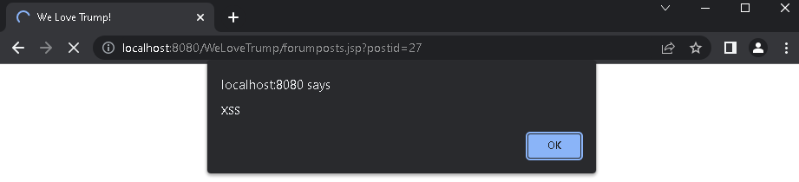

Here is an example of the alert box appearing when the user submitted **“<script>alert(“XSS”)</script>”**

Here is the code that was causing this to happen

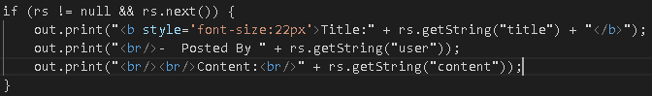

In order to fix this, JSTL taglib was required before the <html> tag

<%@ taglib prefix="c" uri="http://java.sun.com/jsp/jstl/core"%>

Then before the rs.getString() function <c:out value=”<%=rs.getString("blank")%>”/> had to be added so it was able to process in what was being submitted.

The <c:out> is being used as it displays the result of an expression it also escapes XML tags, so they are not evaluated as actual tags themselves.

Here is an image of how it looks with the c:out added



Also the result if a user submits a <script>

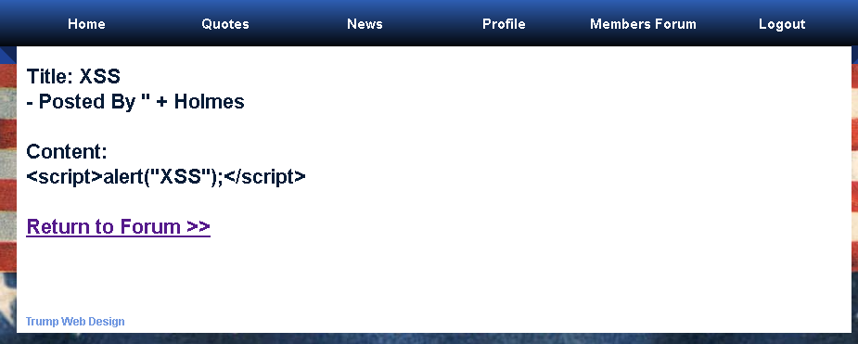

The alert box does not appear on the screen anymore.

**Problem 7**

The 7th vulnerability is Security Logging and Monitoring Failures, I can across it when a user wants to login, whenever they enter a wrong username or even a wrong password it will just return as blank fields instead of returning a text saying “Incorrect Password or Username”

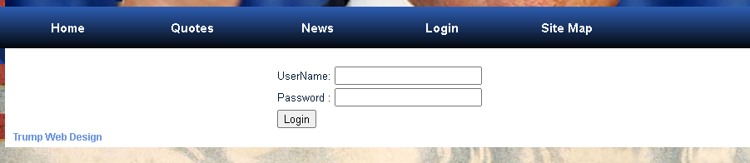

Here is an image how it looks when a user logged in with the wrong credentials

Code:

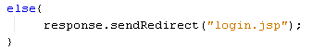

Code is located on line 58 in ValidateLogin.jsp

In order to fix this I had to set a <span> in the login.jsp file and named the span as “errMsg” then in the ValidateLogin.jsp file, in the else block I set the attribute by using the method request.setAttribute() and then just filled it in with “errMsg”, “Incorrect Password or Username” then I added a RequestDispatcher so it can take in request from the client and forward it over to the jsp file.

Here is the code that solved this problem.

ValidateLogin.java

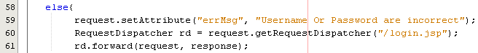

Login.jsp



Result:

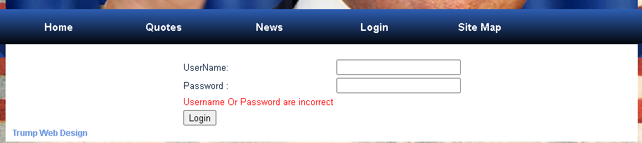

**Problem 8**

The final problem I have found was that a user had the ability to navigate through the URL and has access to the files that had the details of the database such as username and password.

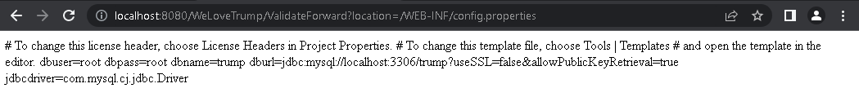

Unfortunately, I wasn’t able to find a fix for this vulnerability. There is something that needs to be worked with in the ValidateForward.jsp but I couldn’t figure out what to do.

Config.properties

